Logical Architecture and Layers?
• The logical architecture is the large-scale organization of the software classes into packages, subsystems, and layers.
• A layer is a very coarse-grained grouping of classes, packages, or subsystems that has cohesive(strongly related) responsibility for a major respect of the system
– E.g. Application Logic and Domain Objects— software objects representing domain concepts (for example, a softwareclass Sale) that fulfill application requirements, such as calculating a sale total

• Typical layers in an OO system includes
– User Interface
– Application Logic and Domain Objects
– Technical Services
    - Application-independent, reusable across systems.
- Relationships between layers:
  - Strict layered architecture: a layer only calls upon services of the layer directly below it.
  - Relaxed layered architecture: a higher layer calls upon several lower layers.

Logical Architecture:
“An architecture is the set of significant decisions about the organization of a software system, the selection of the structure elements and their interfaces by which the system is composed, together with their behavior as specified in the collaboration among those elements, the composition of these structural and behavioral elements into progressively larger subsystems, and the architectural style that guides this organization – these elements and their interfaces, their collaborations, and their composition.”

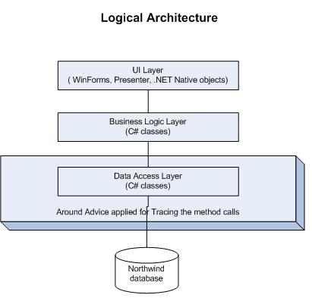

Why using Layers?

Benefits of a Layered Architecture
- Separation of concerns:
E.g., UI objects should not do application logic (a window object should not calculate taxes) nor should a domain layer object create windows or capture mouse events.
  - Reduced coupling and dependencies.
  - Improved cohesion.
  - Increased potential for reuse.
  - Increased clarity.
- Related complexity is encapsulated and decomposable.
- Some layers can be replaced with new implementations.
- Lower layers contain reusable functions.
- Some layers can be distributed.
  - Especially Domain and Technical Services.
- Development by teams is aided by logical segmentation.

Design with Layers
- Organize the large-scale logical structure of a system into discrete layers of distinct, related responsibilities.
  - Cohesive separation of concerns.
  - Lower layers are general services.
  - Higher layers are more application-specific.
- Collaboration and coupling is from higher to lower layers.
  - Lower-to-higher layer coupling is avoided.

Problems when not using layer:
• Application logic is intertwined with the user interface, so
– it cannot be reused with a different interface or distributed to another processing node.
• General technical services are intertwined with application-specific logic, so they
– cannot be reused,
– distributed to another node, or
– easily replaced with a different implementation.
• There is high coupling across different areas of concern.
– It is thus difficult to divide the work along clear boundaries for different developers.

Package Diagram
Package Diagram
- A UML package diagram provides a way to group elements. A UML packages can group anything: classes, other packages, use cases, and so on.
- Package diagram can also show both structure and dependencies between sub-systems or modules
- A package diagram in the Unified Modeling Language depicts the dependencies between the packages that make up a model.
- Package diagram shows the arrangement and organization of model elements in middle to large scale project.
- Packages create a structure for you classes or other Uml element by grouping related elements.

- A package is used to group elements, and provides a namespace for the grouped elements. A package is a namespace for its members, and may contain other packages.
- Owned members of a package should all be package elements.
- The members of the package may be shown within the boundaries of the package.

Dependency:
- One Package depends on another package.

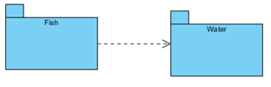
Fish depends on water.

- Package Member are not shown inside the package.
- Package org.hibernate
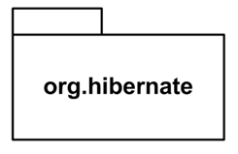
- Package org.hibernate contains SessionFactory and Session.
- Package Member are shown inside the package.
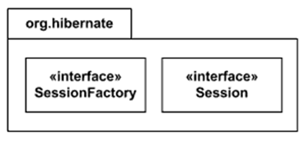

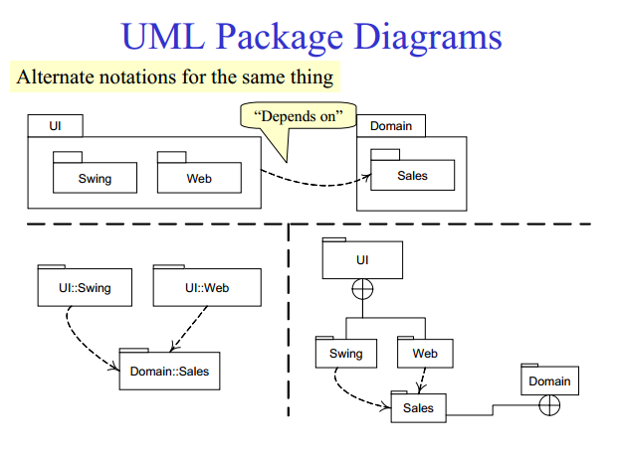

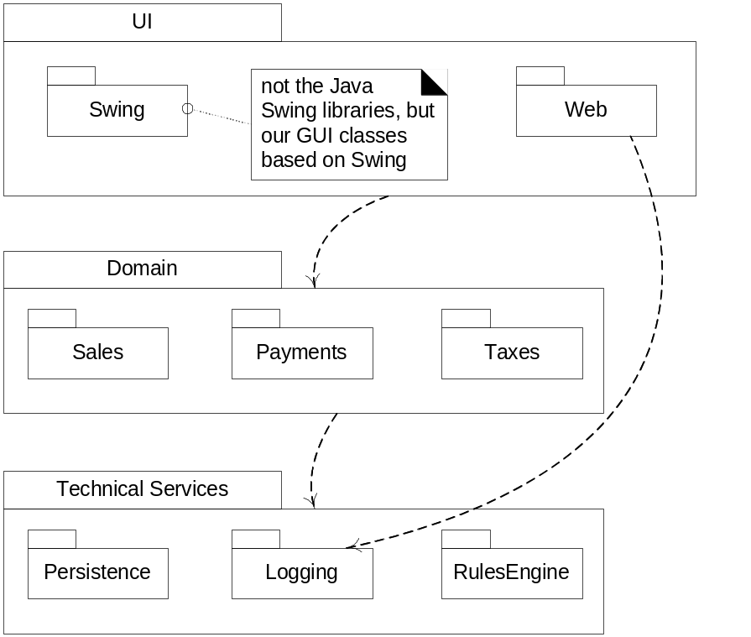

Use of Package Diagram:

- A large complex project can hundreds of classes. Without some way to organization those classes. It becomes impossible to make sense of them all.
- Packages create a structure for you classes or other Uml element by grouping related elements.
- Package diagrams can use packages containing use cases to illustrate the functionality of a software system.

When to use Package Diagram ???

- When you want to show high level view of the system.
- To keep track of dependencies.
- With the large system to show its major element and how they relate to one another.
- To divide a complex system into module
- Package diagrams can use packages that represent the different layers of a software system to illustrate the layered architecture of a software system.

